

**StraboSpot Strat Section Virtual Field Camp Module**

Casey J. Duncan1, Marjorie A. Chan2, Basil Tikoff3

1casey.j.duncan@utah.edu, Dept. of Geology & Geophysics, University of Utah

2marjorie.chan@utah.edu, Dept. of Geology & Geophysics, University of Utah

3basil@geology.wisc.edu, Dept of Geoscience, University of Wisconsin-Madison

www.strabospot.org

**Time: 1-day activity (assumes access to StraboSpot program, ideally accessed through the web API at www.strabospot.org, and some familiarity with its functionality). Can be expanded to longer if you wish, particularly if you choose to have students write a formal field report.**

**StraboSpot and the Justensen’s Flats Dataset, Central Utah**

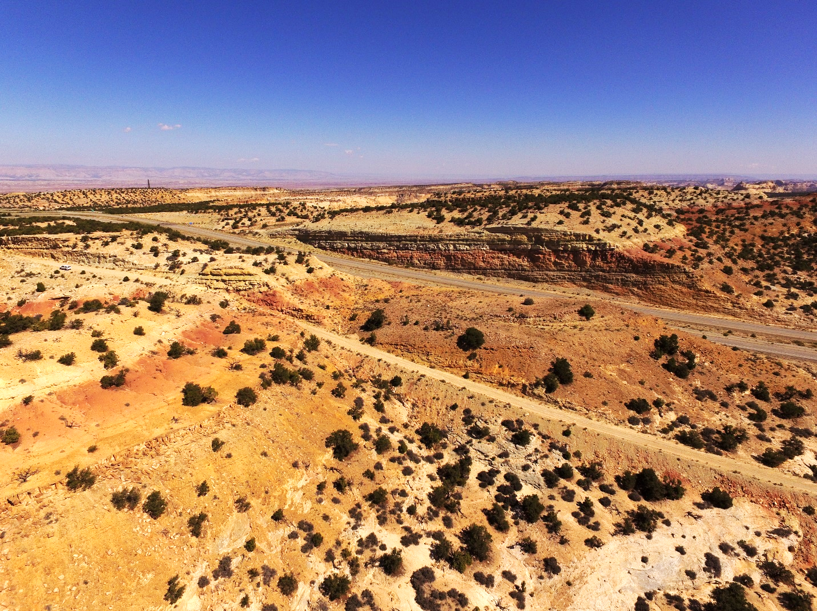

Figure 1. Perspective aerial view of the Jurassic Carmel outcrop (2 parallel roadcuts of mixed carbonate and siliciclastic units) at Justensen's Flats near I-70, Utah. Note the roadways and the suburban in the left-hand side for scale.

Digital Field Notebook

StraboSpot is an NSF-EarthCube funded project to produce a digital data system originally developed for the structural geology community and recently expanded to meet the needs of additional communities, including sedimentology and stratigraphy. StraboSpot serves a critical need for field data collection, database storage, and open data sharing as sedimentology, and geoscience as a whole, transitions to incorporate digital technologies (Montañez & Isaacson, 2013; Chan et al., 2016). The data system consists of a data collection application, both as a free mobile app available for iOS and Android devices and as a web API, with a backend database (www.strabospot.org). StraboSpot operates as a ‘Geologic Information System’ (akin to a *Geographic* Information System) that organizes geologic field data into a database through point, line, and polygon ‘spots’ and ‘tags’ (see Walker et al., 2019).

Jurassic Geology

This module uses a dataset from an excellent exposure of the Jurassic Carmel Formation close to I-70 in the San Rafael Swell, central Utah, U.S.A. (Fig. 1). This outcrop exhibits mixed clastic-carbonate deposits formed following the incursion of the Sundance Seaway into Utah (Wheatley & Chan, 2018). The variable sedimentary lithologies offer the opportunity for description and interpretation of a diverse section, making it a valuable teaching tool. The mixed lithologies show the range of capabilities of StraboSed.

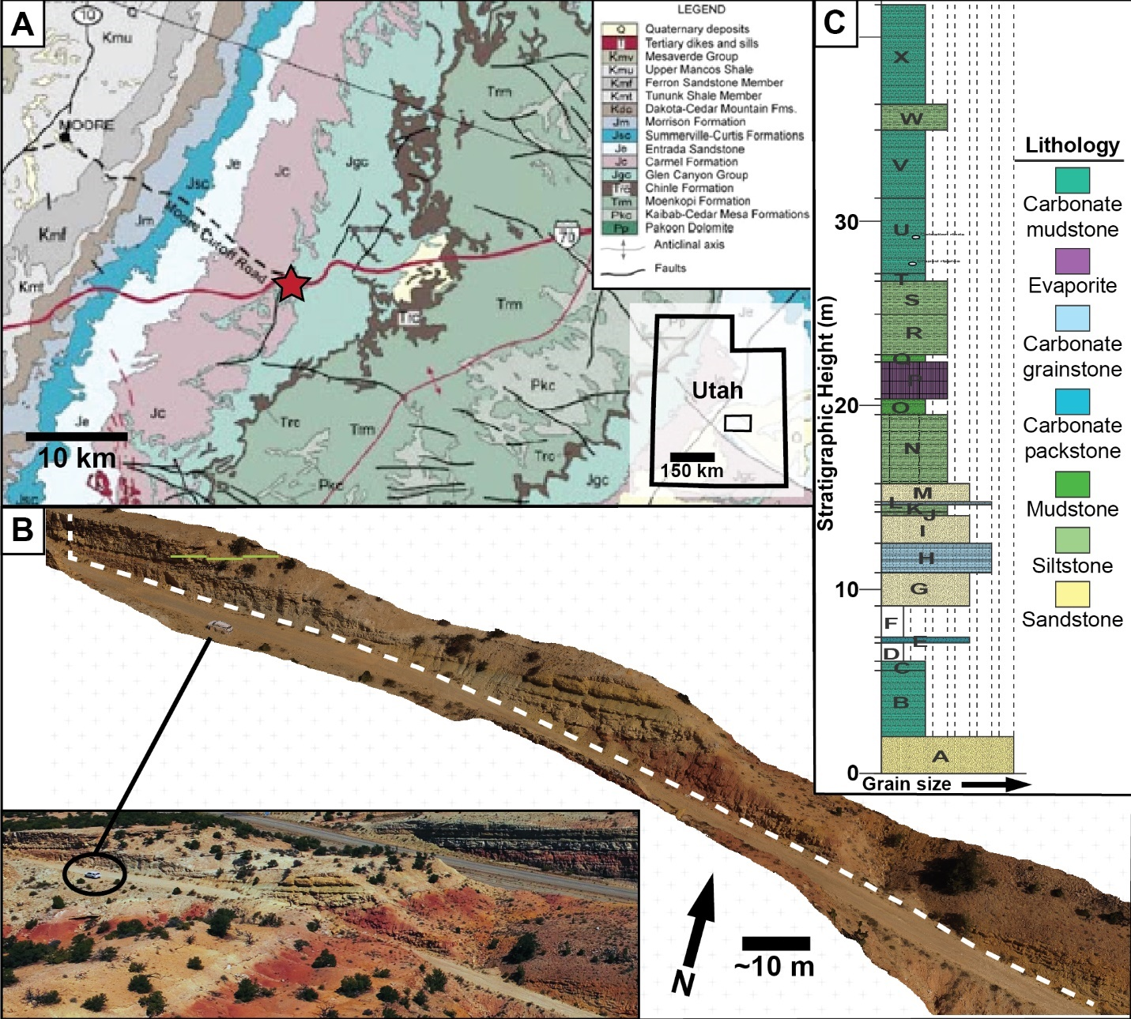

Figure 2. Overall context figure for the Justensen's Flats data set. A) Geologic map (modified after Doelling & Hylland, 2002), showing the outcrop location (red star) in relation to Jurassic stratigraphy (Jgc= Glen Canyon Group, Jc= Carmel Formation). Inset map shows the outline of the map area and its location in Utah (UT). B) Perspective view of the drone-derived 3D outcrop model and the measured section pathway (white dashed line). Inset image is an aerial perspective view of the outcrop. C) Stratigraphic column measured in the field, and exported from StraboSpot and modified in Adobe Illustrator. Capital letters denote ascending sequential described stratigraphic intervals. Section starts in the Jurassic Navajo Sandstone (A) and then works upwards into the overlying Carmel Formation.

In September 2018, we measured and described a stratigraphic section through the lowermost portion of the Carmel Formation near Justensen’s Flats (Fig. 2). This work included description and interpretation of lithologies along the measured section pathway, sample collection, and image collection via an Unmanned Aircraft System (UAS, aka drone) for 3D outcrop modeling. The sedimentological data and samples were collected using StraboSpot in the field, and 3D outcrop models were built with Agisoft Photoscan photogrammetry software. Annotated 3D outcrop model photopans were added to StraboSpot through the web API.

Data Sets

The Justensen’s Flats Project is available and composed of two main datasets, summarized in the table below:

|  |  |  |
| --- | --- | --- |
| **Dataset** | **Description** | **Data** |
| Measured Section | Summary of sedimentological observations for each interval (units A-X), with rock descriptions and images for each interval | Measured section  Measured section pathway  Interval attributes  Interval Images |
| Annotated Outcrop Model | Base maps of annotated screenshots of portions of a UAS-derived 3D outcrop model of the outcrop. Base maps allow for tracking spatial relationships between sample and interval image locations below GPS resolution. Also contains perspective views of an equivalent I-70 road cut. | Annotated outcrop model photopans  Interval thicknesses  Interval images  Sample locations and photos |

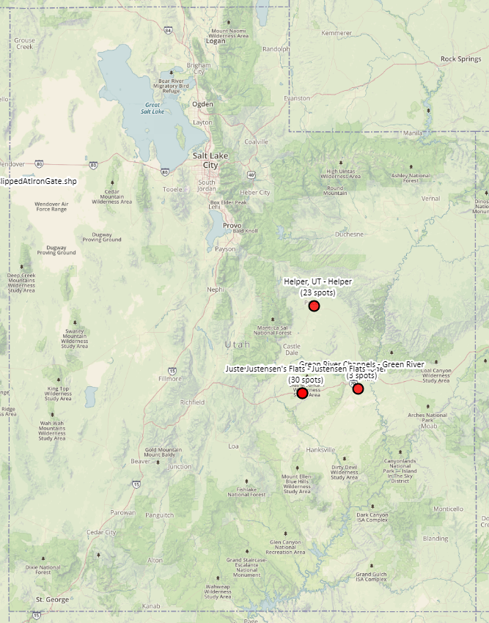

Figure 3 (left). Modified screenshot of the StraboSpot search page showing the State of Utah, and the projects & data sets (red dots) available for this module.

**Utah**

These data sets are available through [www.strabospot.org/search/](http://www.strabospot.org/search#/). To access the projects and data sets, navigate to the search page and pan/zoom to Utah, U.S.A., and the Justensen’s Flats, Green River, and Helper, UT projects for this module will appear (Fig. 3). Selecting the project of interest will make the spots within each data set appear, making it possible to explore the data contained within each spot.

**To access the data set locations directly, go to:**

Justensen’s Flats- Jurassic Carmel Formation on western portion of San Rafael Swell, UT: <https://strabospot.org/search?c=LTEyMzQ2MTI3LjY3NjA1MjM4eDQ2OTk3NjguOTkzMTgwNzYzeDE0Ljc1NzExMjUwODgwNjg2Ng==>

Green River Channels- Cretaceous Cedar Mountain Formation exhumed paleo-channels near Green River UT: <https://strabospot.org/search?c=LTEyMjc4ODYxLjA0ODI2OTk2M3g0NzA1Mjg3LjY5Njk1MDIyM3gxNS4yNDM1MTEwNTcwNzM0Njg=>

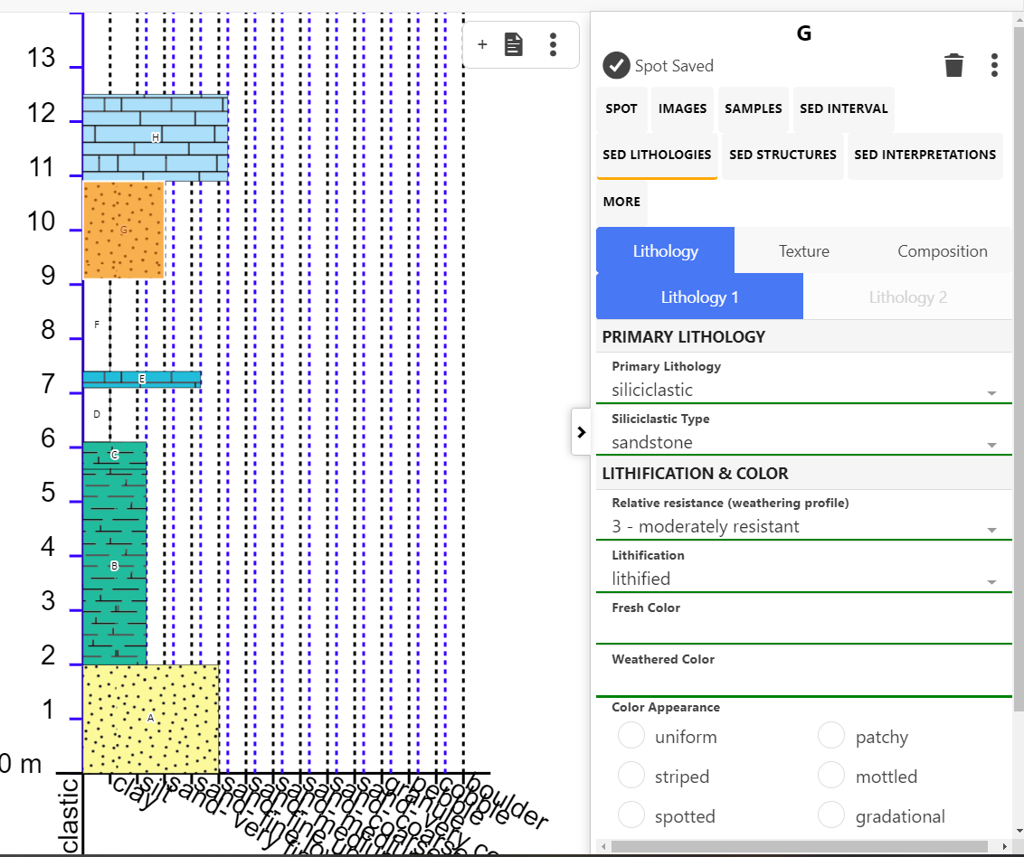

Figure 4. Screenshot of 'Strat Mode' showing the stratigraphic column (on left) and the associeated data for each interval (on right).

**Learning Outcomes**

By completing this module, students should gain:

1. Familiarity with the field notebook workflow to locate themselves, describe sedimentary rocks, and measure a stratigraphic section.
2. An appreciation for and strategies to deal with uncertainties with interpretation of complex stratigraphy.
3. Experience with StraboSpot (sedimentary vocabulary and logical steps of recording data).
4. Ability to synthesize/integrate observations from hand sample- to outcrop-scale to interpret relationships, depositional environments, and architecture.

**Activities**

Students start their own StraboSpot project, either in the iOS/Android mobile app or through the web app ([www.strabospot.org](http://www.strabospot.org)), with main activities for this module including:

* Prepare supporting data: Load in Justensen’s Flats (CarmelOutcropOrtho, Map Code: 5bd343f12b62c) and Cedar Mountain (KcmOrtho, Map Code: 5eab02d68f574) drone orthomosaics, download the pdf field book of the measured section (through the StraboSpot search page, see end of outline).
* Using the annotated model sections and the orthomosaics map trace the measured section pathway (line spot) on the orthomosaics base map.
* Add a stratigraphic section to the section pathway line spot (observations derived from the field book).
* Use Skitch (or sketch function of new release) to annotate the drone models/equivalent I-70 roadcut exposure to make additional observations of surfaces, stratigraphic architecture, etc.
* Add interpretations to each interval.
* Write a short report summarizing observations and discussing possible interpretations (process, environment, uncertainties, etc.).

Exercises

1. SED FIELD NOTEBOOK: Locate yourself on maps (GPS), making field notes & observations, taking & annotating photos.
   1. Students use the device GPS to set a spot at their location (or a location selected from the map if privacy is a concern). Alternatively, the students could use the web API ([www.strabospot.org](http://www.strabospot.org)).
      1. Setup project in StraboSpot
      2. Select a hand sample to use for this activity
      3. Go to Main Map and set a point spot for where you collected your sample
   2. Students add photo of hand sample to spot.
   3. Students add notes and hand sample observations to the spot.
      1. Add notes on the Spot tab
      2. Add sedimentary texture and composition information through the Sed Lithologies tab
   4. For a stretch goal: Students could take a medium-scale photo (e.g. their sidewalk) and use that as a basemap to establish sub-GPS resolution spots. This would get students thinking about device limitations, and the need to track spatial relationships between data points.
2. LITHOFACIES: Distinguish & interpret lithofacies.
   1. Use images from the Cretaceous Cedar Mountain exhumed channels data set to distinguish lithofacies.
   2. Annotate outcrop image with skitch, or set image as base map and demarcate lithofacies through polygonal spots on the outcrop image.
   3. To each lithofacies polygonal spot add sedimentological data and interpretations using the Sed tabs.
3. STRAT SECTIONS: Example of what it is, how we use it to make graphic representations, then interpretations, depositional environments. Then how to make one in your own field area.
   1. Load data used for this exercise
      1. Add Justensen’s Flats drone map: CarmelOutcropOrtho map code: 5bd343f12b62c.
      2. Add Cedar Mountain drone map: KcmOrtho map code: 5eab02d68f574.
   2. Qualitative exploration of measured stratigraphic sections:
      1. Students are given the Justensen’s Flats measured section.
      2. Using the Annotated Outcrop Model data set they compare the measured section with the images of the outcrop and the I-70 road cut.
      3. Compare and contrast the measured section with the outcrop, answer conceptual questions to check understanding.
   3. Construction of a measured section:
      1. Students establish a line spot on the drone orthomosaics showing the measured section pathway
      2. In the line spot students construct a measured section through the Jurassic Carmel (replicating the measured section they’re given),
      3. Alternatively, the same exercise can be performed with the Cretaceous Cedar Mountain near Green River, UT (a simpler section).

**References**

Chan, M.A., Peters, S.E., and Tikoff, B., 2016, The future of field geology, open data sharing and cybertechnology in Earth Science: *The Sedimentary Record*, v. 14, no. 1, p. 4-10, doi: <https://doi.org/10.2110/sedred.2016.1>

Doelling, H.H., Hylland, M.D., 2002, San Rafael Swell proposed as site of new national monument: Survey Notes, v. 34, no. 2, p. 9-11.

Montañez, I.P., and Isaacson, P.E., 2013, A ‘sedimentary record’ of opportunities: *The Sedimentary Record*, v. 11, no. 1, p. 4-9, doi: <https://doi.org/10.2110/sedred.2013.1>

Walker, J.D., Tikoff, B., Newman, J., Clark, R., Ash, J., Good, J., Bunse, E.G., Möller, A., Kahn, M., Williams, R.T., Michels, Z., Andrew, J.E., and Rufledt, C., 2019, StraboSpot data system for structural geology: *Geosphere*, v. 15, no. 2, p. 533-547, doi: <https://doi.org/10.1130/GES02039.1>

Wheatley, D.F., & Chan, M.A., 2018, Clastic pipes and soft-sediment deformation of the Jurassic Carmel Formation, southern Utah, U.S.A.: Implications for pipe formation mechanisms and host-rock controls: *Journal of Sedimentary Research*, v. 88, p. 1076-1095, doi: <https://dx.doi.org/10.2110/jsr.2018.45>.